Office Fraternity and Sorority Life
P.O. Box 6292
198 Lee Blvd Suite 300
Mississippi State, MS 39762
P. 662.325.2394
F. 662.325.3323
www.greeks.msstate.edu

National Pan-Hellenic Council (NPHC)
&
Multicultural Greek Council (MGC)
Membership Intake Guidelines
Spring 2023

SECTION I
Mississippi State University
Guideline Information
Guideline Type
Administrative OFSL Procedure
Responsible Office(s)
Office of Fraternity and Sorority Life

Guideline Approval Date
7/7/2022
Related Policies and University Procedures
Hazing Policy: http://www.policies.msstate.edu/policypdfs/91208.pdf
Student Code of Conduct: http://www.policies.msstate.edu/policypdfs/91100.pdf
COVID-19 Updates: https://www.msstate.edu/coronavirus
Purpose of Intake Guidelines

The Office of Fraternity and Sorority Life (OFSL) at Mississippi State University (MSU) recognizes the importance of the Membership Intake Process and we support your efforts in the development of new members, as well as your chapter. As students continue to seek membership in Greek letter organizations on our campus, it is important that the Office of Fraternity and Sorority Life establish a system of communication with organizations wanting to conduct intake activities for new members.

Each of the affiliate organizations of National Pan-Hellenic Council (NPHC) and Multicultural Greek Council (MGC) exists on the MSU campus because of a collaborative partnership between the two entities. It is important that each chapter understands this relationship and operates within the set policies and procedures of their respective national bodies and the Mississippi State University. In addition, it is equally important that potential new members also understand that they must adhere to these same policies and procedures during the membership intake process by way of making sure that only those requirements listed within each organization’s membership intake process occur, and there are no instances of unauthorized activity. Herein stated, one will find the procedures required by the MSU Office of Fraternity and Sorority Life designed to ensure a smooth intake process. It is important that it be understood that if these guidelines are not followed it will result in actions being taken by the MSU Office of Fraternity and Sorority Life, Dean of Students Office (DOSO), as well as contacting the respective chapter’s advisor and national headquarters. Please handle the intake process with a sense of integrity, civility, and respect.

Membership Intake Standing Rules

- The academic mission of the institution will be upheld and promoted to new members.
- Membership activities will not interfere with academic endeavors or class schedules.
- The selection of new members will be free of any form of mental and/or physical abuse and hazing as defined by our MSU Policy and federal law.
- Members will be selected on the criteria set forth by the national headquarters of the organization.
- Chapters will not engage in pre or post hazing activities.
- Chapter advisors will be present at all membership related activities.
- Chapters must be in good standing (defined as, “financially active with nationals, academically active with nationals and Mississippi State University, not on any type of probation with either nationals or MSU”) with their national headquarters and Mississippi State University prior to intake activities.
- Chapters complete all required paperwork in a timely fashion.
- Prospective members will be made aware of Mississippi State University Hazing Policy.
- No membership activity includes the presence or consumption of alcohol.
- All membership intake activities are to be conducted in compliance with each national organization’s intake guidelines and process.
- All prospective members will attend the NPHC/MGC Interest Meeting before being considered for membership in a NPHC or MGC organization.
- All members will attend the NPHC/MGC member orientation.
- All new member presentation shows are done in a tasteful manner and refrain from utilizing language or activities that allude to any type of pledge process (i.e.- hitting, slapping, referencing DP, Dean of Pledges, Carrying Bricks, physical labor, references to Big Sister, Big Brother, etc.)
- A new member introduction show is a family event, with observers ranging in age. Therefore, out of respect for observers, no new member show should include sexually explicit language, gestures, references, or dismissive actions towards other organizations.
- A chapter must maintain a minimum of a 2.50 cumulative chapter GPA to host membership intake activities. A chapter falling below 2.50 overall average will be placed on membership and social probation the following semester and will remain on probationary status until the overall cumulative average equals or exceeds a 2.50.
- A chapter must maintain a minimum of a 2.50 semester chapter GPA to remain socially active. A chapter falling below a 2.50 semester average will be placed on social probation but may still host membership intake if the cumulative grade point average is above a 2.50. The chapter will remain on social probation until the time that the semester grade point average meets or exceeds a 2.50.
- Organizations will comply with outlined membership intake guidelines prescribed by the MSU Office of Fraternity and Sorority Life.

Yearly Intake Requirement

- All NPHC and MGC member organizations are required to host intake activities for the purpose of gaining new members, during the fall or spring semester of the academic year. An organization may vote to host intake once during both semesters of school year as well.
- The activities should include nationally approved interest meetings, rush, etc. whose direct purpose is to be the first step to becoming a member of a NPHC or MGC sorority or fraternity.
- Should these hosted events yield qualified applicants, the organization is expected to proceed forward with membership intake activities.
- Failure to host an interest meeting, rush, or smoker for the purpose of gaining new members and/or informing potential aspirants about your organization, will lead to the organization being placed on student organization probation status. A review of the chapter’s reasoning for not hosting membership intake activities will occur. If probable reasoning is not providing for forgoing this requirement, the chapter will lose recognized student status.

Privacy Statement

To protect the interests, privacy, and confidentiality of the affiliate chapters of NPHC and MGC, all documents submitted will be treated as confidential information in accordance with Mississippi state law. No one other than the Dean of Students and the Office of Fraternity and Sorority Life staff will have access to any information submitted by a chapter. While access to these documents will be restricted, university administrators, chapter advisors, and/or representatives from the national headquarters will have access on a need-to-know basis.

SECTION II
Mississippi State University
Membership Intake Guidelines
(An additional timeline grid is attached for ease in working with deadlines/dates)
*Notice: To ensure that enough time has been allotted for unexpected occurrences, all paperwork, reservations, etc. should be completed at least 1-2 months prior to the start of intake. The planning process for Membership Intake should begin the semester before your chapter intends to host intake. *
Important Meeting and Dates

NPHC/MGC Interest Meeting

Spring 2023: January 22nd 1pm-3pm Union Ballroom
- All students interested in being considered for membership in one of the active NPHC or MGC organizations are required to attend NPHC/MGC Interest Meeting as a condition of participation in membership intake programs.
- Sessions will be offered during the academic year, at the beginning of the fall and spring semesters. Make-ups will be offered but is only eligible to students who missed due to a class or documented illness.
- All NPHC and MGC Executive board members are required to participate in the NPHC/MGC Interest Meeting.
- Advisors are not required but are invited to attend.
- Chapter members should be prepared to participate in various activities, as the format of the NPHC/MGC Interest Meeting may change from time to time (i.e.- Question Panel, Video, Step presentation, breakout rooms etc.)
- All presentations should be done in a manner that professionally represents the university and the national organization.

CHAPTER COMPLIANCE STEPS
**If deadlines apply to the steps below, then they will be listed after the item. **

Steps to take Pre-Interest Meeting | Comments
Reserve Spaces | : This should be done by the first day of classes  : Remember that you cannot reserve classroom spaces until the first day of classes;  therefore, it is best that you make sure someone is in line at Event Services by 7am the  first day of classes for each semester.  : All other spaces are able to be reserved as early as you would like.  : Reserve space for new member presentation as early as possible. Remember there are limited locations on campus to host new member presentations; therefore, the earlier the better
Cowbell Connect | : Complete Cowbell Connect requests for all reserved spaces immediately after reserving them.  : Remember to complete the request for University Appropriated money
Cowbell Connect Forms | : Complete the Cowbell Connect Event Request Form no less than one (1) month before the date of new member presentation.  : Complete the Appropriation Fund Request Form. This is a separate form from the one done for event requests. Follow these links to the form: Once logged in to Engage -> hover over More tab -> click treasury -> Click Manage Budgets -> complete the budget form  : This should be done 1-2 months prior to the new member presentation
Venue Set Up | : IMPORTANT  : Event set up is a separate process from completing the Engage form  : Failure to complete an event set up may result in your event being cancelled. All venue needs i.e., lighting, chairs, projector usage, etc. should be submitted to the proper office no later than two weeks before the presentation.  : Failure to do so may result in the presentation being cancelled.
Time doors will open | : The chapter is required to be at the venue 1 hour prior to this time.  : If different parties of people are being let in at different times, this needs to be stated in the plan.  : The chapter is responsible for managing the door. OFSL, ushers, nor security will control who is allowed in.
Time event will start | : Events that start more than 20 minutes after the designated start time will result in the chapter receiving a $100 fine to be paid to NPHC or MGC.
Security | : A request for security should be placed no later than two weeks before new member presentation  : Failure to do so will result in the presentation being cancelled.  : Contact MSU Police for security needs  : You need to provide location, approximate attendance (matrix attached)  : Provide them with the new member presentation plan you have completed (example attached)
Clean Up | : The chapter needs to submit a plan including who will be cleaning up venue after the presentation.
Miscellaneous Information | Please submit all other information in the plan that would be deemed beneficial for orchestrating a successful and efficient event.

Step 1. INTAKE MEETING- If your organization plans to conduct an intake process, the chapter president and/or new membership chairperson is required to meet with the NPHC/MGC Advisor or a designated member of the Fraternity and Sorority Life. During the meeting, be prepared to review your national requirements for Intake. Be prepared to submit documentation that certifies your chapter’s eligibility for Intake. Please include appropriate name, telephone number, and email address for state and/or regional officers of your organization. Also, you will be expected to bring a calendar/schedule of activities for the organization, and the official flyer announcing the informational/interest/rush meeting. Please include date of informational, date expected to send off applications, interview dates, ritual dates, study dates, date of new member presentation show, and all other dates related to the Intake process.

ADVISOR AGREEMENT/NATIONALS APPROVAL- Please submit proof of approval from your national organization once it has been acquired. Advisor Agreement Form must accompany letter of approval from national organization. (Must be submitted at Intake Meeting)

Step 2. INTEREST MEETINGS/RUSH (etc.)
- Informational meetings, interest meetings, or awareness seminars may take place during the time periods listed above.
- Eligibility Release and Hazing Policy Notification Forms (see forms section) must be given to each student attending the previously mentioned meetings. ALL Eligibility Release and Hazing Policy Notification forms must be returned to Office of Fraternity and Sorority Life within 48 hours of the conclusion of the aforementioned meeting. Sign in sheets must be submitted of EVERYONE who attended the interest meeting.
- Location, Date, and Time of meeting must be included in the letter of intent. The interest meeting/rush must be submitted and approved no later than 48 hours in advance of the event.
- A copy of the interest meeting/rush flyer must be submitted to the NPHC/MGC Advisor.
Step 3. HAZING COMPLIANCE FORM- This form must be brought to the intake meeting and contain all required signatures. The form will note the chapter and organization and contain signatures from the chapter president and membership intake chair. Must be submitted at Intake Meeting.

**All forms must be completed and submitted before new member presentation will be approved**

Step 4. NEW MEMBER PRESENTATIONS- The chapter is completely responsible for reservation of venue, security, and other logistical details as they apply to new member presentations. In order to be in accordance with university policies and procedures, the chapter will need to submit a plan to OFSL concerning how the new member presentation will be run. An example of a new member presentation plan can be found on page 12 as well as in the forms packet. This plan should include the following information:

Information to be included in plan | Comments
Date of Presentation | This date should be included on your intake calendar.
Venue | : Reserve venue for New member presentation. This should be done as close to the start of the semester as possible. Space availability declines as we get further into the semester.  : Contact Event Services: 662-325-3228, so that they may direct you on set up needs.  The NPHC/MGC Advisor will also provide assistance when requested.
Cowbell Connect Forms | : Complete the Cowbell Connect Event Request Form no less than one (1) month before the date of new member presentation.  : It is important that you regularly check this form, as  : Complete the Appropriation Fund Request Form. This is a separate form from the one done for event requests. Follow these links to the form: Once logged in to Cowbell Connect -> hover over More tab -> click treasury -> Click Manage Budgets -> complete the budget form  : This should be done 1-2 months prior to the new member presentation
Venue Set Up | : IMPORTANT  : Event set up is a separate process from completing the Cowbell Connect form  : Failure to complete an event set up may result in your event being cancelled. All venue needs i.e., lighting, chairs, projector usage, etc. should be submitted to the proper office no later than two weeks before the presentation.  : Failure to do so may result in the presentation being cancelled.
Time doors will open | : The chapter is required to be at the venue 1 hour prior to this time.  : If different parties of people are being let in at different times, this needs to be stated in the plan.  : The chapter is responsible for managing the door. OFSL, ushers, nor security will control who is allowed in.
Time event will start | : Events that start more than 20 minutes after the designated start time will result in the chapter receiving a $100 fine to be paid to NPHC or MGC.
Security | : A request for security should be placed no later than two weeks before new member presentation  : Failure to do so will result in the presentation being cancelled.  : Contact MSU Police for security needs  : You need to provide location, approximate attendance (matrix attached)  : Provide them with the New member presentation Plan you have completed (example attached)
Clean Up | : The chapter needs to submit a plan including who will be cleaning up venue after the presentation.
Miscellaneous Information | Please submit all other information in the plan that would be deemed beneficial for orchestrating a successful and efficient event.

**IMPORTANT** Failure to submit a drawn-out plan for New Member Presentations will result in the chapter no longer being able to host new member presentations.

Step 9. COMMUNICATION- The Office of Fraternity and Sorority Life expects communication with each organization to be an open process. Should timelines change, it is an expectation that all the steps of the process are communicated with the NPHC/MGC Advisor or a designated member of the OFSL staff immediately. Any organization that fails to follow the proscribed process or guidelines will be subject to all activities being ceased.

Note: See New Member Intake Schedule for specific dates and deadlines. All dates are final unless prior approval has been received from a designated staff member of The Office of Fraternity and Sorority Life and Dean of Students Office.
ADDITIONAL NOTES

**EXTENTIONS- All intake activities must be complete by or before April 1, 2023. There are no exceptions to this rule.

**DEADLINES- February 13th, 2023. This is the last day to submit and Membership Intake Forms unless you have been approved for an extension.

**CEASE ACTIVITIES- April 1, 2023
All intake activities must cease. Sanctions will be given to those organizations that do not adhere to this deadline.
New Member Retreat: All newly initiated students will be required to participate in the NPHC/MGC New Member Retreat the following fall.

OFSL Meeting: All chapters are required to schedule a time for a member of the MSU OFSL Staff to come meet with verified applicants to discuss expectations of being a new NPHC or MGC member.

Contact Information
Questions or concerns should be directed to The Office of Fraternity and Sorority Life
Director for Fraternity and Sorority Life:
John Michael VanHorn
662-325-3917 (Office)
Jmv82@saffairs.msstate.edu (email)

TIMELINE SNAPSHOT
Guideline | Description | Deadline | Submission  Requirements
NPHC/MGC Interest Meeting | NPHC/MGC Committed Prospective Meeting is the first official introduction that students have to Greek Life. All Students participating in intake must attend. | January 22nd, 2023 | All NPHC and MGC Exec must attend. Prospective members must complete sign in.
Intake Meeting and Advisor Verification | An Intake Meeting must be scheduled with The Office of Fraternity and Sorority Life to discuss the chapter’s calendar and plan for dates. The President, Intake Coordinator, and Advisor must attend this meeting. Advisors are asked to submit their Verification Form at the time of the meeting. | *Must be scheduled and held two weeks prior to initial interest meeting. | What you will need at meeting: Calendar of Activities, Notice of Intake Form, Advisor Verification, Hazing Compliance Form, Proof of Approval for Intake from National Office, and copy of flyer.
Interest Meetings/Rush | Organizations may host advertised interest meetings and Rush Activities. Must be submitted to the NPHC/MGC Advisor 10 days prior to the interest meeting/rush. These activities must take prior to a pre-determined date. All participants must complete an Intake Eligibility Release Form and Hazing Policy Notification Form. These must be submitted to The Office of Fraternity and Sorority Life. |  | Chapter must submit a copy of the flyer. Each Attendee must complete 2 Forms: Intake Eligibility Release Form, and Hazing Policy Notification Form. The Chapter must submit these to OFSL within 48 hours of the interest meeting.
Intake Verification Form | Once the chapter has determined who is eligible and approved by the National Organization to participate in Intake, then they must submit the Verification of Aspirants form, listing each potential member. Once submitted, any changes in that list must also be documented to the OFSL. | Must be turned in prior to new member presentation being approved. | Chapter must submit Verification of Aspirant Form. Each aspirant must complete the Hazing Policy New Member Compliance Form.
New Member Presentation Plan | In order to be in accordance with university policies and procedures, the chapter will need to submit a plan to OFSL concerning how the new member presentation will be run. **see chart above** | Must be turned in two weeks prior to new member presentation | Failure to submit a drawn-out plan for New Member Presentations will result in the chapter no longer being able to host new member presentations.
Cease Activity | Chapters may no longer have activity. Including new member presentations, ceremonies, crossings, meetings, etc. after this date. | April 1, 2023 | NO MORE ACTIVITIES ALLOWED AFTER THIS DAY

Mississippi State University
National Pan-Hellenic Council
Multicultural Greek Council
Appendix

Attachments:
- Police and Security cost matrix
- Example of New Member Presentation Plan
- Mississippi State Hazing Policy

Police and Security Cost Matrix

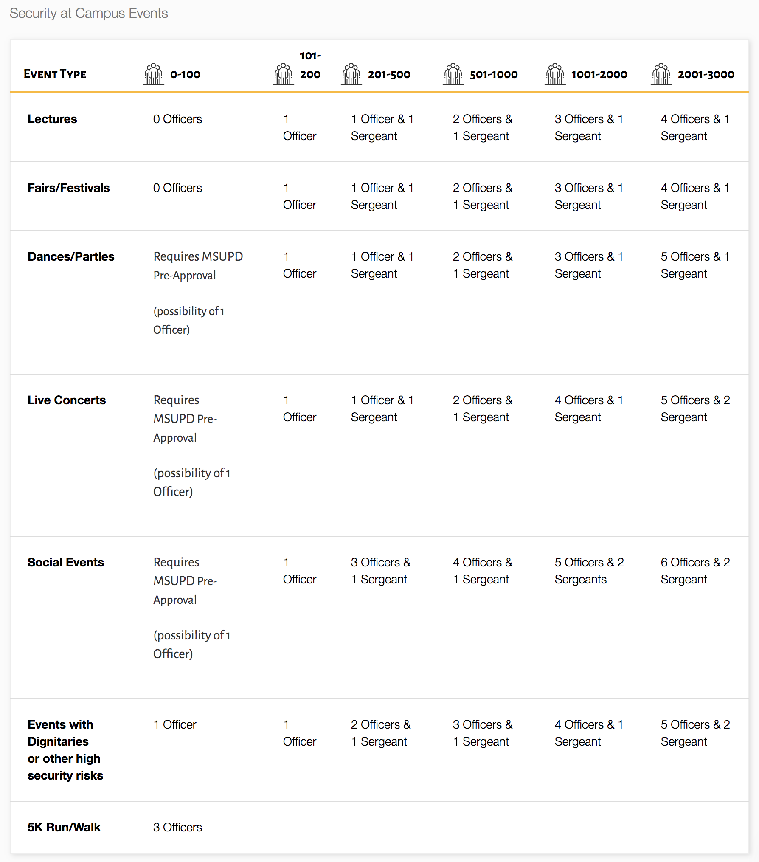

Example of New Member Presentation Plan

I hope all is well with you. This email serves as a response to the new NPHC and MGC Intake Policy, concerning Neophyte presentation shows. We the insert chapter of insert organization, want to make sure that we are doing all we can to ensure the enjoyment and safety of all in attendance. As such, we have spoken with the NPHC/MGC Advisor to discuss the best way of moving forward with our new member presentation. Herein stated are the details of our conversation.
In order for us to abide by the structure set by our national constitution and the University, we have to have it on insert date of new member presentation. Insert location has been booking by insert name of responsible party, and the set-up is also complete. We will also have insert number of confirmed ushers (if using Lee Hall) people serving as ushers for this presentation.
As we understand the concern regarding security and managing the amount of people that will come, insert responsible party has spoken with the MSU Police Department. We as the insert chapter have agreed to help security manage our event. It is impossible for us to guarantee that no incident will happen; however, we feel that we have taken the measures necessary to put in place safeguards that will ensure our program is a great experience for all in attendance.
Brothers/Sisters of the chapter name will report to insert location at specify time
Entrance into the Neophyte Presentation:
Family Members will enter from specify time
Members of insert organization name will enter from specify time
Greeks will enter from specify time
General Public will enter from specify time
The show will start at specify time
Family members and members of insert organization will understand that they have to be on time. If they are not there at their designated times, then we will continue with the seating schedule.
The members of insert chapter will make sure that the entrance schedule remains accurate, and that people are being seated properly.
As this is a free event, we will make sure that our ushers standing at the doors will keep count of the amount of people that are let in on each level of Bettersworth Auditorium. Once capacity is reached on each level, no more individuals will be allowed access. (only for events in Lee Hall)
As for cleanup, the current members and the new members of the insert chapter and organization will handle cleaning insert location. I, insert name of responsible party, have had a conversation with the chapter. The chapter understand that any member that leaves prior to the venue space being clean will face consequences in line with their actions and may cause the chapter to be placed on probation, fined, or any other consequences aligned with the Mississippi State Membership Intake Guidelines and the NPHC or MGC Constitution.
As for advertising, we will advertise using social media and word of mouth on campus. We are also familiar with the advertising policies that are instated on campus.
Insert advisor name, our advisor, has stated that she/he will be there before, during, and after the event to make sure that all items outlined in this email take place.
Should you have any concerns or questions please do not hesitate to contact me:
Insert Name
- Insert contact number
- Insert email
Best wishes

Mississippi State Hazing Policy

National Pan-Hellenic Council and Multicultural Greek Council Hazing Policy:

All members of the MSU NPHC and MGC are also held accountable for the National Council’s Joint Position Statement Against Hazing. All chapter officers are responsible for knowing and/or educating their chapter members about this policy. A complete description of the policy can be downloaded at:

http://www.nphchq.org/docs/NPCHJointPostionsStatemetnAgainstHazing2003.pdf

Mississippi State University Hazing Policy:

STUDENT AFFAIRS OP 91.208: Hazing Policy

Approved: October 11, 2017

Purpose

To provide uniform guidelines for the protection of the University community against the dangers associated with of hazing.

Policy

Hazing is prohibited. Any student and/or group failing to comply with this policy is subject to disciplinary action as defined by the Student Code of Conduct. In addition to being in violation of the University hazing policy additional charges are possible both as an organization and as individuals engaged in hazing. Under certain circumstances, hazing may be a violation of the laws of the State of Mississippi, resulting in a criminal prosecution by state and/or local officials. Depending on the circumstances surrounding the hazing activities, responsible parties may be charged with either a misdemeanor or felony.

For purposes of this policy, hazing is defined as:

Any act, regardless of the person’s willingness to participate, that endangers the mental or physical health or safety of a student, or that destroys or removes public or private property; and/or assisting, directing, or in any way causing others to participate in degrading behavior and/or behavior that causes ridicule, humiliation, or embarrassment; and/or engaging in conduct which brings the reputation of the organization, group, or University into disrepute for the purpose of initiation, admission into, affiliation with, or as a condition for continued membership in a group or organization; or as part of any activity of a sponsored or registered student organization.

Any requirement that compels a member or new member, regardless of the person’s willingness, to participate in any activity that is illegal, or that is contrary to any rules or regulations of the University.

Any acts that unreasonably or unusually, impair a member's or new member's academic efforts.

Reporting:

A hazing incident may be reported by anyone by contacting the Dean of Students Office or University Police. All reports of hazing behavior will be investigated, including those reported anonymously. However, please be aware that the University’s ability to investigate hazing incidents depends on the accuracy and specificity of the information provided.

Violations:

Violations of the intake process may result in probation or suspension. Whether the chapter will be placed on probation or receive automatic suspension is based upon the infractions and is at the discretion of the Director of Student Activities and NPHC or MGC Graduate Advisor.

Probation is noted by a period of scrutiny wherein if the chapter commits any violation of the intake process or any other rules set forth by the advisors or the Office of Fraternity & Sorority Life, the chapter will be placed on suspension. Suspension is noted by a period wherein all social and formal programming (this includes community service, all fundraising activities, and intake functions) is prohibited. The suspension period will be determined by the Office of Fraternity & Sorority Life and will be a time of no less than one semester. In the event that the chapter is disciplined as outlined above, the regional and national leadership of the fraternity/sorority will be notified.

Violations include:

- Intentional submission of improper paperwork (i.e., changing of dates on forms, falsifying original signatures, incomplete paperwork, etc.)
- Holding membership intake without adhering to the Intake Guidelines set by the Office of Fraternity and Sorority Life.
- Hazing: Any violations of the MSU Hazing Policy will result in a referral to the Dean of Students.
- Overt activity defined as any activity related to intake conducted in defiance of previous guidelines or warnings by council advisors.
- Failure to adhere to Presentation of New Member Guidelines (as included in this packet).

Guidelines for Review of Chapter Status for Suspension:

- Executive Board: Chapter President and/or 1 representative must be present.
- The Chapter Advisors must be present (both Faculty and Graduate Chapter advisors).
- The Director of Student Activities and Coordinator for Fraternity and Sorority Life.

All questions and concerns must be expressed by the Chapter President to the Office of Fraternity & Sorority Life. If any questions regarding the Guidelines arise, they may be discussed between the Chapter President, Intake Coordinator, Chapter Advisors, and the Office of Fraternity & Sorority Life. Final jurisdiction and decision-making authority rests in the hands of the Office of Fraternity & Sorority Life. Students found guilty of hazing will be subject to penalties outlined in Student Code of Conduct, the University Dean of Students Office, as well as any sanctions outlined by the national organization.

Without the submission of the required paperwork, intake will not be approved. In the event that the intake activities begin without the knowledge and signed approval of the Director of Student Activities and Coordinator for Fraternity and Sorority Life, and/or the chapter has not adhered to these written Intake Guidelines, intake activities will cease immediately, and the chapter may be placed on suspension. In addition, the regional and national leadership of the fraternity/sorority will be notified. These sanctions will be administered appropriately at the discretion of the Director of Student Activities and Coordinator for Fraternity and Sorority Life or, if applicable, the Dean of Students Office.

